Diwali Celebrations At Your School
v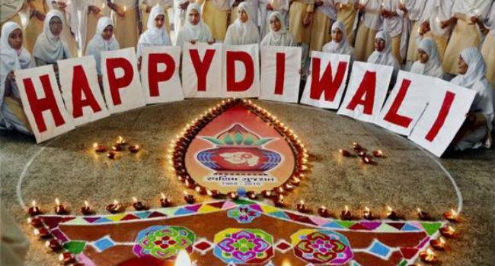
The celebration of Diwali, the festival of lights, came alive when the whole school wore a festive look with pots, diyas and lanterns adorning the reception and corridors of the school. The rangoli on the theme of eco-friendly Diwali by the students of all the four houses added the perfect setting to the festivity.
Diwali is known as the “celebration of lights.”
A holiday celebrated by Hindus, Jains, and Sikhs each year in either October or November (dates vary from year to year, based on the Indian lunar calendar), Diwali represents the triumph of good over evil and light over darkness. Diwali is a terrific holiday to teach in a classroom, rich with legend and tradition. Since it lasts five days, it is the perfect length for a week’s worth of classroom activities and lessons.
Diwali is in part a celebration of Prince Rama returning to his land of Ayodhya after rescuing his wife Sita from the demon King, Ravana.
For the full story, readers of all ages can find free resources online. The Maxwell School of Syracuse University offers long, short, and illustrated versions of the epic legend, known as the Ramayana.
Students can also engage in learning about the holiday in school. Below are six hands-on activities were done during in N.K.B.P.S
1. Hosted a mela.
During Diwali, Indian villages host melas, or street fairs, where vendors sell produce and handmade goods. Classes at an arts-and-crafts day and barter at a school-wide mela, where students swap their own drawings and interpretations of the illustrated scrolls, manuscripts, and other artifacts that can be viewed via the Metropolitan Museum of Art’s online database.
2. Put on a performance.
The Ramayana is rich with lively, over-the-top characters (a monkey king!) that lend themselves well to a child’s imaginative interpretation. Students did play the roles of Rama and Ravana, or they can be members of the monkey army aiding Rama in his triumph over evil. Students transformed the story into a script, and design their own costumes from a box full of accessories and props.
3. Be bright.
During the “Festival of Lights,” Hindu, Jain, and Sikh households and yards are alight with clay lamps, strings of electric bulbs, fireworks, and bonfires, all in honor of Lakshmi, the goddess of wealth. Students can decorate the classroom with LED candles as well as their own handmade scrolls and manuscripts, and they can view photos of South Asian households decorated for the holiday.
Students were also asked to interpret “brightness” or “goodness” in various ways, and to consider how these constitute a part of their everyday lives. In dedicated storytelling sessions, students can present objects that are meaningful to them and develop a myth or legend around the significance.
4. Eat!
Sweets are an important part of Diwali celebrations. Being mindful of any student allergies, participants prepared easy no-bake doodh-peda using just a few simple ingredients. Or have kids research and exchange recipes they can make at home, and report back to the class with their results (in the form of treats!).
5. Learn about family.
The fifth and final day of Diwali, known as Bhai Dooj, is a celebration of siblings. On this day, sisters and brothers exchange gifts and celebrate their love and affection for each other. In the spirit of the day, but with consideration to children who do not have siblings, students created family trees and trace their genealogies.
6. Map mythological lands.
Teachers considered turning the story of Diwali into a longer, month-long study of mythology and the epic. There are age-specific retellings and resources available to teach the Odyssey, the Iliad, and Greek myths. An imaginative project can ask students to draw maps of the various lands and locales in which these myths take place; this encourages students to apply spatial reasoning, history, and inventiveness, all in line with project-based learning curricular methods.
During the season of “traditional” U.S. holiday celebrations, introducing students to the traditions of Diwali can engage them with rich literary, artistic, and historical traditions — a feat certainly worth celebrating.
On Dhanteras, the first day of Diwali, people clean their homes in preparation for Goddess Lakshmi who is welcomed into people’s homes. The second of day of Diwali is called Nakak Chaturdasi and it is on this day that people decorate their doorways and homes with rangoli and other traditional designs to welcome in the gods during Diwali.
The rangoli is considered to bring good luck and can be made by anyone. People will also start bursting crackers on this day and celebrate with friends and family for the coming day of Diwali. It is is customary to wear new clothes on the day before and day of Diwali.
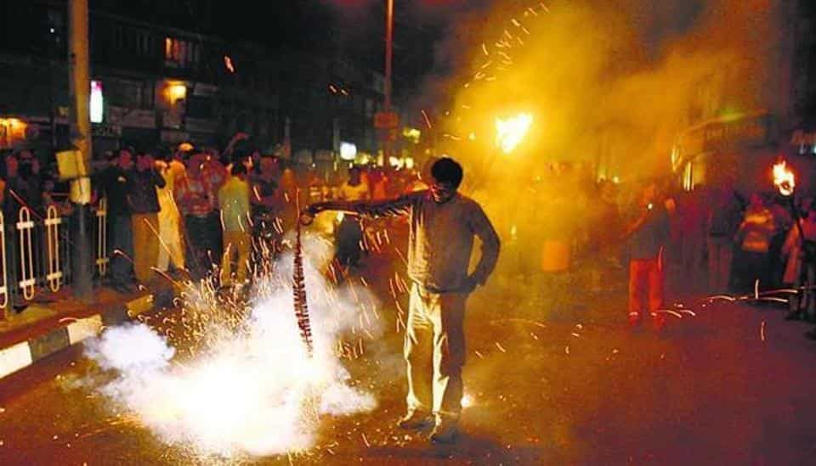
But this time and all the time some people take a step to stop burning of crackers . Delhi Government stopped burning of crackers
N.K .Bagrodia. Public.School., rallied through their nearest are like , sec -6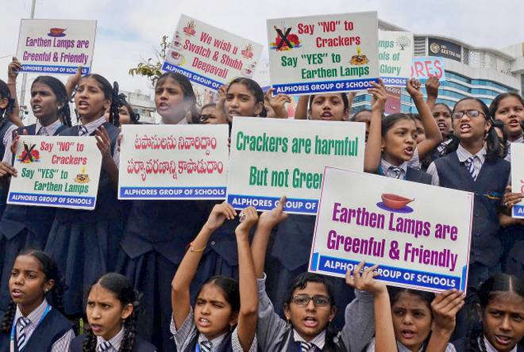
v

