Name: Ishita Mahajan
CLASs : 9th SeC: D
School: Guru Harkrishan Public School, Hargobind Enclave , Delhi -92

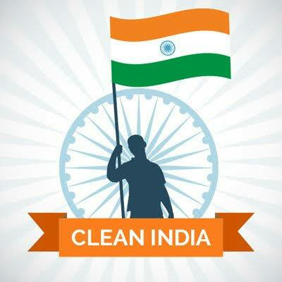
<<clean India>>

INSERT YOUR IMAGE

<<!!! श्री कृष्ण !!!
Dear Readers,
My name ishita Mahajan. First of all I want to wish you “Happy Diwali”.
Today, I shall talk only about the Cleanliness.
According to me every Indian want a Clean India. That is why Clean India Mission launched as a national campaign by the Indian Government in order to covering the 4041 statutory towns aiming maintained cleanliness of streets, roads and infrastructure of the country. It is the biggest cleanliness drive ever in India when approximately 3 million government employees including students from schools and colleges took part in the cleanliness activities.

This mission aimed to join each and every Indian people from all walks of life by making the structure of branching of a tree. Swachh Bharat mission aimed to construct individual sanitary latrines for household purposes for the people living under poverty line, converting dry latrines into low-cost sanitary latrines, provide facility of hand pumping, safe and secure bathing, set up sanitary marts, construct drains, disposal of solid and liquid wastes, enhance health and education awareness, provide household and environmental sanitation facilities and many more.
To ensure cleanliness in the official buildings of UP, chewing paan, gutka and other tobacco products has been banned by the Government of Uttar Pradesh.
Other programmes like Swachh Bharat Run, Swachh Bharat apps, Real-time monitoring system, Swachh Bharat short film, Swachh Bharat Nepal – Swasth Bharat Nepal Abhiyan and so many has been initiated and implemented to actively support the purpose of the mission. In order to continue and make this campaign successful, Finance Ministry of India has started a programme named Swachh Bharat cess. According to this, everyone has to pay .5% more service tax on all the services in India (50 paise per 100 rupees) which will go to this cleanliness .
I think, Cleanliness should be initiated at home, school, college, society, community, office, organization and country level to bring a clean India revolution all over the India. We need to clean ourselves, home, surrounding areas, society, community, city, garden, and environment on daily basis. We all should understand the motto, importance and necessity of cleanliness and must try to apply it in our daily lives. Cleanliness among students in the schools are promoted through many activities like cleaning of school campus, classrooms, labs, poster making on cleanliness, waste segregation, essay writing, painting on cleanliness, poems recitation, group discussion, documentary videos etc.

Cleanliness is the state of keeping clean and remains away from dirt to achieve and maintain the good physical and mental health.
A small step from the end of every Indian citizen can be a big step for fulfilling the purpose of the ‘Clean India’ campaign.
In the last I hope that you shall also participate in this campaign to Clean India.
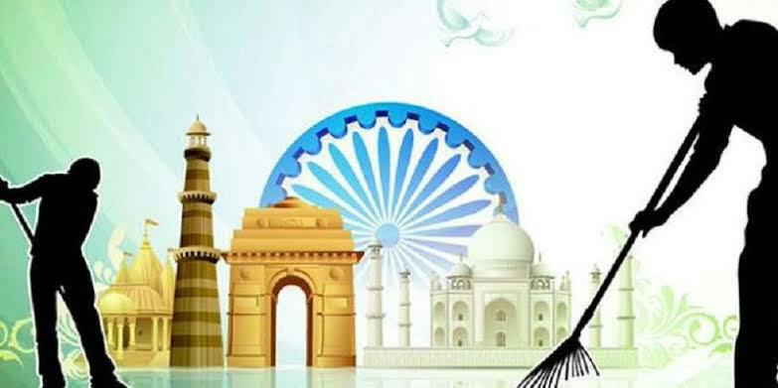
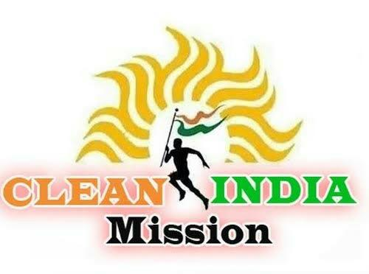
Thanks for reading my Report >>

INSERT YOUR IMAGE

INSERT YOUR IMAGE

INSERT YOUR IMAGE

INSERT YOUR IMAGE

