Name: divyapreet kaur bindra
CLASS: 12th SeC: e
School: guru harkrishan public school , poorvi marg , vasant vihar ,
new delhi -110057

A Glimpse of Diwali celebration in our School
By – Divyapreet bindra
I belong to a Sikh Community school which teaches us the values of not only of our religion but also teaches how to respect the culture and traditions of other religions. I really feel excited in writing this article so that I can share how we celebrate Diwali in our religion and what is the significance behind it .
BANDHI CHORR DIWAS has a great significance in sikh history which coincides with the day of Diwali
Sikhs historically celebrated Diwali along with Hindus , with Guru Amar Das Ji explicitly listing it along with vaisakhi as a festival of Sikhs . In late 20th century , sikh religious leaders increasingly called Diwali as Bandhi chorr Diwas and we adopted this name along with the sikh calendar
According to sikh history , on this day , (Guru) Hargobind sahib ji was set to be released only on one condition , that the other 52 kings in prision of Mughal Emperor Jahangir, along with him can be set free . on this day 52 other kings along with himself. DAY OF RELEASE OF THE KINGS IS CELEBRATED AS BANDHI CHORR DIWAS .
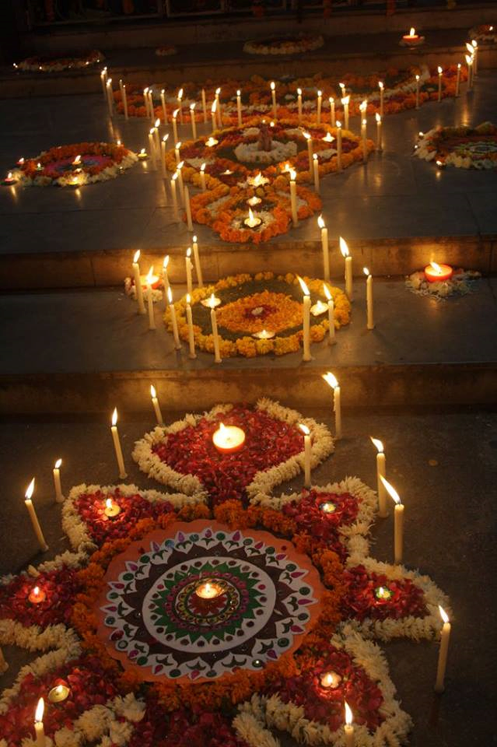
On this day we all the students of the school Decorated our school with various types of Rangolis , Lights and candles etc. We decorate our school Gurudwara sahib ji with lights , flowers & candles etc .
Students did PATH and ARDAAS and Greeted everyone and gave best wishes to everyone .Later, Kadah Prasad was distributed among the gathered sangat.
This was followed by dance programs and musical show followed by some most adorable fancy dress ramp walk by our school’s primary students.
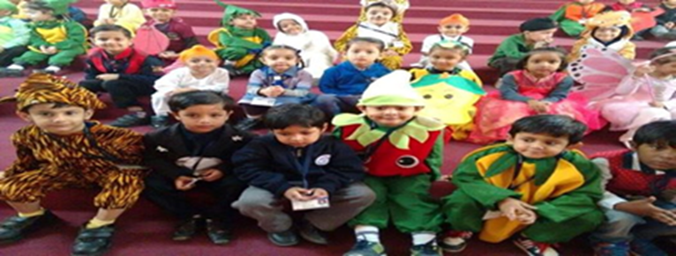

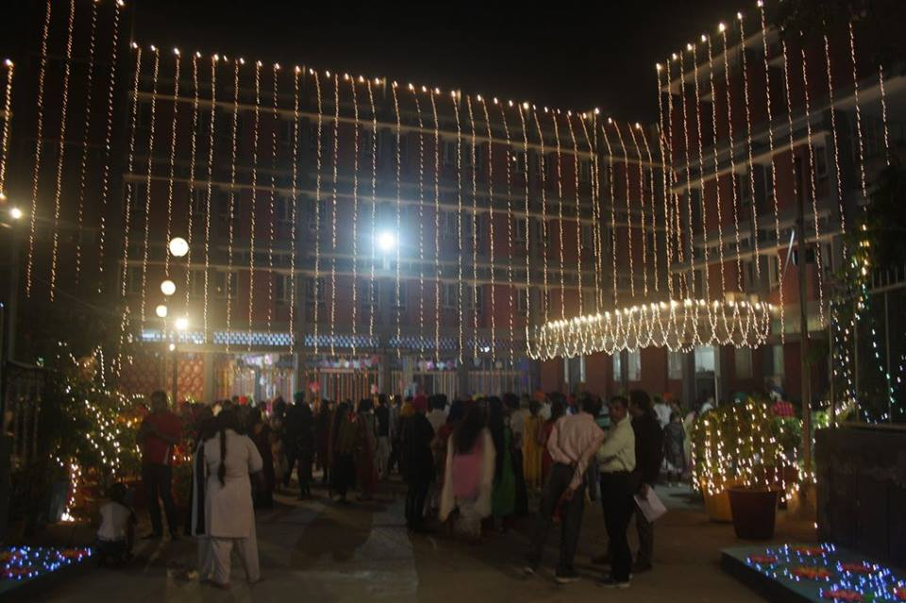

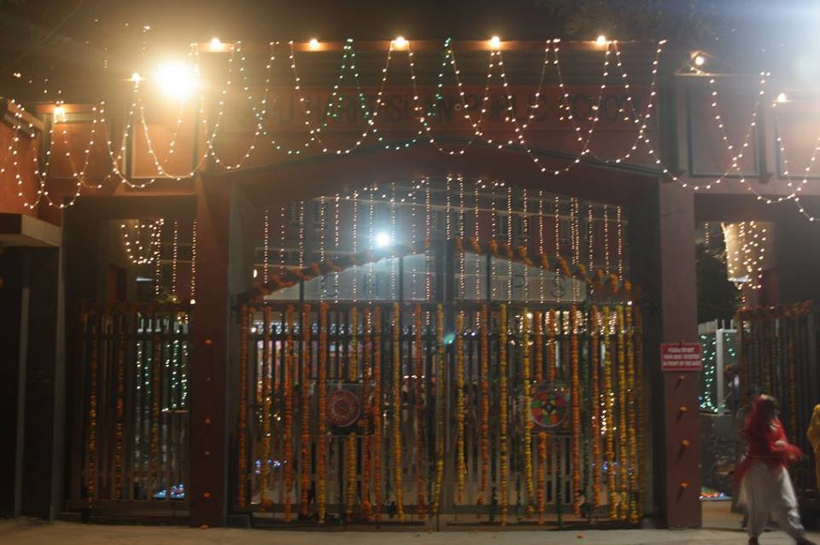
Our Principal Ma’am Dr. Mrs. Sukhwant Kaur greeted the students and the staff members and everyone a very prosperous and happy Diwali and bandhi chorr diwas
Our Vice Principal Mr. Amardeep Singh ji sir along with Principal ma’am blessed all the children for a good year ahead , thus we all celebrate a pollution free Diwali with heart full of good for each other.
-------------------------------------------------------------------------------------------------------------

