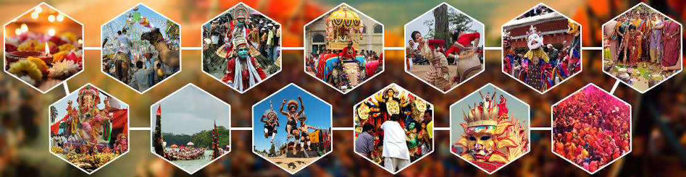Festivity with traditional fervor!!!!!!!
By-Manshika Nagpal

We all live in a world which is full of diverse people, diverse religion, diverse mindset, diverse clothing and eating. But there is one thing which is common in this world and that is festival and fervor for it.

Festivals are not just for eating, doing fashion, doing party and gossiping they are all about connecting with old ones, removing all the hatred towards each other, forgiving everyone,making someone smile without any reason and making enemies your friends.
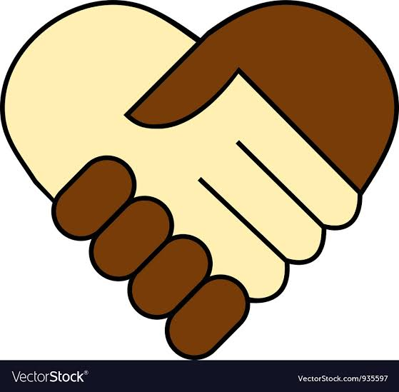
(Forget all the hatred and make your friends your enemy)
Out of 360 days there are some special days which have their own meaning and importance,some are to welcome the seasons of the year ,some are to celebrate the birthdays of divine beings and saints, or the advent of the New Year and these are called festivals.These festivals are common to most parts of India. However, they may be called by different names in various parts of the country or may be celebrated in a different fashion.
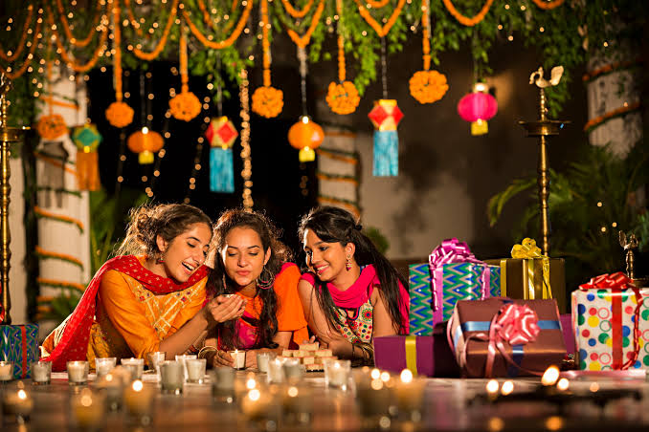
(Diwali celebration)

Each and every festival have it's own way of celebrating like Diwali is celebrated by burning crackers, worshiping Ganesh Ji and Parvati Ji, making rangoli etc whereas holi is celebrated with colours and water.We all know how to celebrate the festival but out of 100 only 40 or 30 people know why to celebrate it which is the clear proof that the festivals has lost their values. Nowdays we are moving away from the real meaning of festivals for example now a days we celebrate diwali just for the sake of burning crakers whereas Diwali is celebrated to honor Rama-chandra, the seventh avatar (incarnation of the god Vishnu). It is believed that on this day Rama returned to his people after 14 years of exile during which he fought and won a battle against the demons and the demon king, Ravana.Today the equation has shifted towards money ,you wouldn’t be surprised to find people working on festivals and concentrating on their careers rather spend time with their families.

Therefore in some years we would be celebrating all our traditional festivals similar to Valentine’s day, Father’s Day, Mother’s day, etc. all commercially driven.

(Thanks for reading)

